JECRC
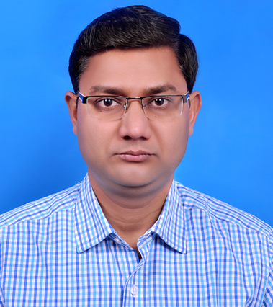photogaph
JAIPUR

INDIVIDUAL FACULTY DATA SHEET
Name of the faculty member |  | : Dr. Lokesh Kumar Bansal
Present Designation | : | Professor & Head
Email Id: hod.ece@jecrc.ac.in
Contact Details: 9251039858

I. Particulars of Educational Qualification: (only completed)

Category | Name of the Degree | Specialization | Year of Passing | Name of the College | Name of the University
UG | B.E. | Electronics Engg. | 1998 | B.D.C.O.E., Sewagram | Nagpur University
PG | M.E. | Comm., Control & Networking | 2002 | M.I.T.S., Gwalior | R.G.P.V., Bhopal
Ph.D. | Ph.D. | Wireless Communication | 2013 | M.I.T.S., Gwalior | R.G.P.V., Bhopal

II. Academic Experience : 18 Years

III. Industrial Experience : Nil

IV. Title of Ph.D. Thesis : Performance Study of Space-Time Coded MC-CDMA Systems

V. Awards/Achievements : Awarded as best faculty member

VI. Research/Specialization : Wireless Communication

VII. Course Taught : Digital Electronics, Microprocessor, etc.

VIII. Refereed International Journal Publication : 09

IX. International Conference Proceeding : 14

X. Books Written : Nil

XI. M.Tech Thesis Guided : Nil

XII. PHD Thesis Guided : Nil

XIII. Professional Body Membership : Yes; Institute of Engineers (India), ISTE

